Theory of Centrifugal Spacecraft: Applications, Methods, and Implications

Ryan White, University of Queensland

One of the biggest problems in today’s space industry is the reliance on short term manned missions to conduct science in microgravity or to journey to extra-terrestrial locations. Arguably the most compelling argument to ensure human wellbeing on long-termed missions in microgravity is the utilisation of centrifugal-structured spacecraft, which may be rotated at a constant angular velocity to essentially ‘fake’ gravity in space. Centrifugal structures in future spacecraft will no doubt usher in a new age of space exploration that focuses on human wellbeing in long journeys; promoting an increase in productivity and safer mission outcomes. As well as more effective missions, centrifugal structures open the idea of long-term, or even permanent, colonies in microgravity as a result of associated health benefits. This essay will explore the science behind centrifugal structures (including the relevant forces), arguments against the design with appropriate counter-arguments as well as the benefits of centrifugal structures as opposed to conventional (and often dated) spacecraft design.

As the name implies, a centrifugal structure is designed to uniformly distribute a centrifugal acceleration across the inside of a cylindrically designed assembly. The structure in itself can’t produce gravity, even though we’d all really like it to, but after being accelerated into a constant rotational velocity, the spacecraft’s ‘edge’ (assuming it is structurally capable of rotating at such velocity) produces a normal force that can counteract the centrifugal force of a person standing against the vessel. The relationship between centripetal acceleration (equal and opposite to centrifugal acceleration), angular velocity and radius (of the spacecraft) may be seen in Equation 1.

Equation 1: Relationship between centripetal acceleration, angular velocity and radius.

$$a_{c}=ω^{2}r$$

Due to the radius being a key part in the equation, differences in radius of objects cannot be ignored, such as the difference in radii between a human’s feet and their head: which creates artificial tidal force. It’s not hard to recognise that there would be a reduction in experienced artificial gravity where angular velocity is constant and radius is reduced, meaning that a human (or any object for that matter) would experience a **greater** centrifugal force at their feet than at their head (due to distance from the pivot of the spacecraft – the radius – at their feet being larger than at their head). For the sake of human wellbeing and comfort, this artificial tidal force should be reduced as much as possible, which brings several problems. Equation 2 shows the relationship between the artificial tidal force (difference of artificial gravity between the feet and head) and the radius of the spacecraft’s centrifuge.

Equation 2: Relationship between Tidal Acceleration, object height and spacecraft radius.

$$Δa_{c}=\frac{a_{c}h}{r}$$

As determined by equation 2, the tidal acceleration follows an inverse relationship to the radius of the spacecraft. This means that as the radius increases, the tidal acceleration is reduced for some centrifugal acceleration at the edge of the spacecraft. For spacecraft with a tidal acceleration of 1% Earth’s gravity (0.098m.s­-1) and an example human height of 1.8m, the spacecraft radius must be in excess of 180 meters, necessitating extremely large spacecraft for the sake of long term human health. This brings multiple problems with it, providing very real arguments against the use of centrifugal spacecraft.

Despite all of the potential benefits of rotational motion in large scale spacecraft, there are numerous problems associated with both the design and function of such rotating centrifuges. Firstly, neglecting the economics of large scale centrifugal spacecraft, the vacuum of space is an incredibly dangerous environment, bearing a multitude of potential catastrophes to spacecraft. Dangers such as debris from functional or expired satellites, meteoroids, or even asteroids all pose significant threats to the hull of such spacecraft, where a sufficiently large object (or cluster of objects) could expose the inside of the spacecraft to the vacuum or damage essential parts of the spacecraft. Unfortunately, as the radius of the centrifuge increases (benefiting human health - by reducing artificial tidal force - and extending the longevity of potential human-stays aboard said spacecraft), the risk of such impacts occurring increases faster than a square law (as per the quadratic equation for surface area of a cylinder, see Appendix 2). Dangers could be minimised by reducing the effective surface area of the structure, although this is a danger facing all space craft (not just centrifuges) and will not be explored further. A very real, and reasonably unique, problem facing centrifugal spacecraft is the necessitation for adequate support structures to allow for (potentially) high angular velocities and the centrifugal accelerations associated with them. Assuming no easily attainable super-strong materials are invented in the recent future, an increase in supporting material carries with it an increase in mass and inherent cost. This cost would greatly inhibit any likelihood of such a large design being constructed. One possibility to avoid launching excessive masses (and hence dollars) off Earth would be to mine natural satellites of Earth (or any other body) to gather any and all resources that are already in orbit. As the majority of Δv, the change in velocity required to transfer to a certain orbit, of a spacecraft is expended in the launch sequence (Appendix 3), minimising the mass at launch (by sourcing mass from objects already in orbit) reduces the effective potential energy required at launch to produce the same spacecraft.

Despite the number of detrimental characteristics and requirements for large-scale centrifuges, the benefits may very well outweigh any setbacks. The microgravity environment of orbit is known to be harmful to humans in the long-term, affecting bone density which is very detrimental to humans upon return to Earth’s surface gravity. To help counteract the effects of microgravity on the human body, astronauts are required to exercise hours daily to maintain their health. If this duration of exercise were to be reduced (by minimising the need for exercise due to the presence of some ‘gravitational’ acceleration from the spacecraft’s rotational motion), productivity of missions could be increased and consequently be made more cost efficient per unit time of operation. In addition to this, operations could increase in longevity due to the astronauts onboard no longer needing to return to Earth to avoid long-term health damage as a result of extended exposure to microgravity. This outcome implies a range of additional uses of spacecraft, such as long-term or permanent colonies, science-vessels etc.

Although centrifuge-based spacecraft designs carry with them numerous problems and associated risks, the potential benefits of their utilisation cannot be ignored. As humans are no doubt destined to travel the cosmos, it would be irresponsible to neglect our long-term health and wellbeing, even for relatively short journeys on the order of months. Artificial gravity from rotational motion is the future of space travel, and at the very least it is a practical and elegant application of simple physics.

**Appendices:**

Appendix 1: Derivation of Equation 2:

$$Δa_{c}=a_{c_{2}}-a_{c_{1}} \\ Δa_{c}=ω^{2}r_{2}-ω^{2}r_{1} \\ Δa_{c}=ω^{2}\left(r_{2}-r_{1}\right) \\ Δa_{c}=ω^{2}h \\ Δa_{c}=\frac{a_{c}h}{r}$$

Appendix 2: Surface Area of a Cylinder

$$Surface Area=SA=2πr^{2}+2πrH$$

Appendix 3: Delta-V required to transfer to various orbits

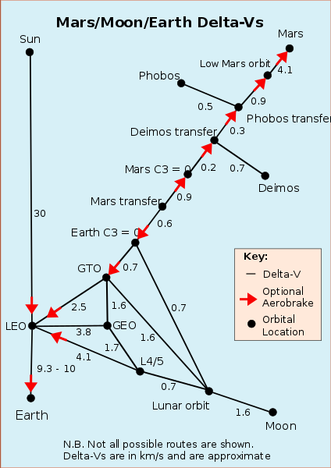

(source: Wikipedia user Wolfkeeper, retrieved 22nd June, 2018 from https://en.wikipedia.org/wiki/File:Deltavs.svg)